

Requirements Analysis (Deliverables 1 and 2)

CS 6354 – Advanced Software Engineering, Section 581
Summer 2007



The Fantastic 9

Arturo Saracho | axs067000@utdallas.edu | 11120701
Denis Stetsenko | dxs067000@utdallas.edu | 10829000
Sarthak Dudhara | skd051000@utdallas.edu | 11138921
Abdullah Azzouni | ama063100@utdallas.edu | 11152135
Russell Smith | rss061000@utdallas.edu | 11126187
Anitha John | akj041000@utdallas.edu | 10480080
Abhishek Goyal | axg056100@utdallas.edu | 11139363
Nate Gardner | njg011100@utdallas.edu | 10080880
Sheetal Umeshkumar | sxu054000@utdallas.edu | 11108292

Revision History
Version | Date | Comments | Author
1.0 | 6/7/2007 | Initial Version -- Template | D. Stetsenko
1.1 | 6/8/2007 | Section 3.2 | D. Stetsenko  N. Gardner
1.2 | 6/11/2007 | Section 3.4.1 | R. Smith  S. Dudhara
1.3 | 6/11/2007 | Section 3.4.2 | A. Saracho  A. Azzouni
1.4 | 6/11/2007 | Sections 1, 2, 3.1 | A. John
1.5 | 6/11/2007 | Section 3.3 | A. Goyal
1.6 | 6/13/2007 | Section 3.2 integration, reordering & cleanup | D. Stetsenko
1.7 | 6/16/2007 | Section 2 & Proof-reading | A. John
1.8 | 6/17/2007 | Class Diagram (Object Model) | R. Smith
1.9 | 6/17/2007 | Part of section 3.4.5 Dynamic Model | A. Saracho  A. Azzouni  A. John
1.10 | 6/18/2007 | Added numbers to functional requirements for traceability and captions to a few figures. | A. Saracho
2.0 | 6/19/2007 | Consolidated the whole document as a whole by combining all the parts | S. Dudhara
2.01 | 6/20/07 | Replaced Sheetal’s Sequence diagrams with new ones, replaced prototype screenshots and edited User Interface section | D. Stetsenko
2.02 | 6/20/07 | Made slight changes to the document and some formatting. | A. Goyal
Table of Contents

Purpose of this document 7
Audience 7
1 Introduction 7
1.1 Purpose 7
1.2 Scope of the System 7
1.3 Objectives and Success Criteria of the Project 7
1.4 Acronyms and Abbreviations 7
1.5 References 8
1.6 Overview 8
2 Current System 8
3 Proposed System 8
3.1 Overview 8
3.2 Functional Requirements 8
3.2.1 Logging In 9
3.2.2 Dispatcher Settings 9
3.2.3 Data Entry 9
3.2.4 Data Entry Corrections/Suggestions 9
3.2.5 Caller Address Location 9
3.2.6 Duplicate Calls Detection 9
3.2.7 Ambulance Location 10
3.2.8 No Available Ambulances 10
3.2.9 Exception Message 10
3.2.10 Communication with the Ambulance 10
3.2.11 Hospital Availability 10
3.2.12 Monitoring Performance and Position 10
3.2.13 Monitor Display 11
3.2.14 Monitoring Complete 11
3.2.15 Information Logging 11
3.2.16 Emergency Transfer/Sharing 11
3.2.17 Logging Out 11
3.3 Non Functional Requirements 11
3.3.1 Usability 12
3.3.2 Reliability 12
3.3.3 Performance 12
3.3.4 Supportability 12
3.3.5 Implementation 12
3.3.6 Packaging 13
3.3.7 Legal 13
3.3.8 Security 13
3.3.9 Scalability 13
3.3.10 Schedule Constraints 13
3.3.11 Standards Constraints 13
3.3.12 Budget Constraints 13
3.4 System Models 14
3.4.1 Scenarios 14
3.4.2 Use Case Model 17
3.4.3 Use Cases 18
3.4.4 Object Model 24
3.4.5 Dynamic Model 27
3.4.6 User Interface: Navigational Paths and Screen Mock Ups 41
3.5 Glossary 47

List of Figures
Figure 1. ADS+ Use Case Diagram 17
Figure 2 Class Diagram 26
Figure 3 : Trace Phone Call 27
Figure 4 Place Phone Call 27
Figure 5 Trace By Address 28
Figure 6 Track Case 28
Figure 7 Deliver Case 29
Figure 8 Pick-Up Case 30
Figure 9 Dispatch Nearest Ambulance 31
Figure 10 Create Ambulance 32
Figure 11 Modify Ambulance 33
Figure 12 Delete Ambulance 34
Figure 13 Locate Case Site 34
Figure 14 Locate Nearest Available Hospital 35
Figure 15 Login 35
Figure 16 Create User 36
Figure 17 Modify User 36
Figure 18 Delete User 37
Figure 19 Close Case 38
Figure 20 Modify Case 39
Figure 21 Open Case 40
Figure 22 Login Screen 42
Figure 23 Active Emergencies Screen 43
Figure 24 New Emergency Screen 44
Figure 25 Emergency Details Screen 45

List of Tables

Table 1 : Acronyms and Abbreviations 7
Table 2 : PlacePhoneCall Specification 18
Table 3 : TraceByAddress 18
Table 4 : TraceByArea 18
Table 5 : Gather Information 19
Table 6 : Open Case 19
Table 7 : Track Ambulance 20
Table 8 : Locate Case Site Specification 20
Table 9 : Dispatch Nearest Ambulance Specification 20
Table 10 : Locate Nearest Available Hospital Specifications 20
Table 11 : Track Case Specifications 20
Table 12 : Modify Case Specifications 20
Table 13 : Pick Up Case Specifications 22
Table 14 : Deliver Case Specifications 22
Table 15 : Logon Specifications 22
Table 16 : Display Reports Specifications 23
Table 17 : Create User Specifications 23
Table 18 : Modify User Specifications 23
Table 19 : Delete User Specifications 24
Table 20 : Retrieve Logs Specifications 24
Table 21 : Create Ambulance Specifications 24
Table 22 : Modify Ambulance Specifications 24
Table 23 : Delete Ambulance Specifications 24

Purpose of this document

The results of the requirements elicitation and the analysis activities are documented in the Requirements Analysis Document (RAD). This document completely describes the system in terms of functional and nonfunctional requirements and serves as a contractual basis between the client and the developers.

Audience

The audience for the RAD includes the client, the users, the project management, the system analysts, and the system designers. The first part of the document, including use cases and nonfunctional requirements, is written during requirements elicitation. The formalization of the specification in terms of object models is written during analysis. We use an example template for a RAD introduced in the book.

1 Introduction

The Ambulance Dispatch System (ADS) is a web based tool to allow the administration of emergency response system. It maintains locations of ambulances that can be dynamically configured at administration time. The system maintains a history of response results for analysis.

1.1 Purpose

The purpose of the ADS is to enhance the capabilities of 911 ambulance dispatchers in the timely displacement of ambulance(s) to injury scenes in an efficient manner.

1.2 Scope of the System

The scope of the ADS starts at the moment the dispatcher gathers information from the caller and ends at the patient(s) arrival to a hospital.

1.3 Objectives and Success Criteria of the Project

The ADS will enable an ambulance dispatcher to monitor the whereabouts of dispatched ambulance(s).

Acronyms and Abbreviations

Table 1: Acronyms and Abbreviations

ADS | Ambulance Dispatch System
RAD | Requirements Analysis Document, this document.
MTBF | Mean Time Between Failure
MTTR | Mean Time To Repair
GPS | Global Positioning System - uses satellites to triangulate positions on earth.

1.5 References

[1] http://www.utdallas.edu/~chung/CS6354/
[2] http://wwwbruegge.informatik.tu-muenchen.de/twiki/bin/view/OOSE/RequirementsAnalysisDocumentTemplate
[3] http://en.wikipedia.org/wiki/Dispatcher

1.6 Overview

Fantastic 9’s goal is to build an ADS that will greatly enhance the innovative ideas of public safety dispatchers by sending immediate response to help/resolve an emergency situation.

2 Current System

The current system is a manual, paper-trail process. The 911 operator would take in the emergency call, write down necessary information from the caller, & manually locate a free/idle ambulance. Without having an automated computer system, there is no guarantee the operator will locate a nearest available ambulance on time. The operator will have to call each ambulance to see which one can be dispatched to the site. This process is time consuming & risky depending on the severity of the emergency situation.

3 Proposed System

3.1 Overview

Calling 911 and asking for the ambulance service would connect the caller to a dispatcher who feeds the information s/he receives from the caller into the system. The system would allocate & mobilize a suitable ambulance within 3 minutes, transmit details to the selected vehicle, and track and monitor actual performance and position. An exception message shall be generated if no free ambulance is available for at least 11 minutes. The system would show the location of each patient, the nearest three ambulances, and the nearest available hospitals.

3.2 Functional Requirements

The Ambulance Dispatch System supports the following users: the dispatcher and the ambulance driver. The dispatcher tasks consist of logging into the system, emergency data entry, monitoring the progress of the system, and logging out of the system. The ambulance driver is the key person to respond to the status queries. This setup leads to the following functional requirements:

3.2.1 Logging In

Req. 1 The dispatcher shall log into the system by entering his/her dispatcher identification number and password.
Req. 2 The dispatcher identification number shall be a 5 digit decimal number.
Req. 3 The dispatcher password, an 8 character long alphanumeric string, shall be defined by the dispatcher.
Req. 4 After logging in, the dispatcher shall be taken to the dispatch home screen.

3.2.2 Dispatcher Settings

Req. 5 The dispatcher shall be able to change his/her password and other settings related to his/her account.

3.2.3 Data Entry

Req. 6 After answering a call, the dispatcher shall gather and enter the information into the system.

3.2.4 Data Entry Corrections/Suggestions

Req. 7 The system shall correct formatting errors and offer suggestions (i.e. allow address and emergency abbreviations) to the dispatcher during the data entry process.

3.2.5 Caller Address Location

Req. 8 As soon as the call is received, the system shall automatically start the address location procedures based on the caller's phone number.
Req. 9 If successful, the dispatcher shall verify the address with the caller.
Req. 10 If not, the dispatcher shall ask the caller about his/her location.

3.2.6 Duplicate Calls Detection

Req. 11 The system shall detect potential duplicate calls (calls from 2 or more people describing the same emergency) by performing a quick comparison of the locations and emergency descriptions of all incoming calls and notifying responsible dispatchers if a similar emergency is already in the system.

3.2.7 Ambulance Location

Req. 12 The system shall locate the 3 available ambulances that are closest to the emergency location and present them to the dispatcher in a graphical format, i.e. by displaying a map and marking locations of the emergency and the ambulances.
Req. 13 After the dispatcher chooses one of them the system should transmit the emergency information to the ambulance's mobile receiving unit and start the status monitoring process.

3.2.8 No Available Ambulances

Req. 14 In case the system cannot find any available ambulances in the area, the system shall query the status of the ambulances currently allocated to other emergencies, select 3 that are soon-to-be-available, and present them to the dispatcher. He/she should make the final decision.

3.2.9 Exception Message

Req. 15 An exception message shall be generated for the dispatcher if no ambulance is allocated within 11 minutes of the dispatcher's data entry.
Req. 16 This exception message shall read: "ERROR: NO AMBULANCES HAVE BEEN ALLOCATED".
Req. 17 Upon receiving this message, the dispatcher shall be required to manually select an ambulance by entering the ambulance's identification number.
Req. 18 Ambulance identification numbers shall be 3 hexadecimal digits.

3.2.10 Communication with the Ambulance

Req. 19 The system shall have an interface to communicate with the ambulance driver.
Req. 20 The system shall allow sending the emergency information to the ambulance as well as querying the ambulance about the status of the emergency.

3.2.11 Hospital Availability

Req. 21 As soon as the dispatcher allocates an ambulance to the emergency, the system should present him/her with 3 hospitals closest to the emergency location.
Req. 22 The dispatcher shall make his/her choice, after which the system will transmit this information to the ambulance in charge.

3.2.12 Monitoring Performance and Position

Req. 23 The system shall track the ambulance’s performance and position.
Req. 24 The ambulance's performance shall be based on the time it takes to arrive at the scene once allocated and the time to get the patient to the hospital.
Req. 25 The ambulance's position shall be displayed on the map for the dispatcher to monitor.

3.2.13 Monitor Display

Req. 26 The dispatcher's monitor shall display the following data after s/he has completed the data entry:

• The location of the emergency
• The location of the ambulance(s) in route to the emergency.
• The location of the nearest three ambulances to the emergency location.
• The location of the nearest 3 hospitals to the emergency location.

3.2.14 Monitoring Complete

Req. 27 The dispatcher shall close out the monitoring of an emergency once the allocated ambulance(s) has/have arrived at a hospital.
Req. 28 The dispatcher shall click "Emergency Resolved" to close out the monitoring phase of the dispatch system.
Req. 29 The dispatcher shall be returned to the dispatch home screen when clicking "Emergency Resolved".
Req. 30 The dispatcher can also go to an open emergency request to see its status.

3.2.15 Information Logging

Req. 31 The system shall log all calls and the related emergency information for future review and statistical purposes.

3.2.16 Emergency Transfer/Sharing

Req. 32 The dispatcher shall be able to transfer the emergency to another dispatcher in case s/he has to log out of the system.
Req. 33 The dispatcher shall also be able to share the emergency information with other dispatchers in case he/she needs help.

3.2.17 Logging Out

Req. 34 The dispatcher shall log out of the system by clicking "Log Out".
Req. 35 The dispatcher shall not be allowed to log out while currently monitoring an ongoing emergency unless s/he transferred or shared the emergency with at least one other dispatcher.

3.3 Non Functional Requirements

3.3.1 Usability

Simple to Operate: The software should be easy to learn and operate; the user should not require special skills or training to operate the system.
Simple design: The user interface should be kept as simple as possible so as not to make the application too confusing for the user to understand i.e., user friendly interface.
User awareness: User manual and in-build help file will be provided for the user. Tool tip text will also be provided for quick help.

3.3.2 Reliability

The system should be up and running 24 X 7 X 365 and should be crash safe during 95% of its runtime.
Mean time between failures (MTBF): The MTBF (if any) should not be less than 6 months.
Mean time to repair (MTTR): In case of a failure that leads to a system outage, the MTTR should not be more than 2 hours.

3.3.3 Performance

Short response time: Any page of the application should not take more than 4 seconds to load. The load time of the application should not be more than 4 seconds.
Population Support: The application should be able to support 250 concurrent users without any performance degradation.

3.3.4 Supportability

Advanced technologies: As technology is changing so fast, the system should be able to support new technologies for tracking which will be faster and reliable than the ones present now.
GPS: The system should be able to support GPS tracking in the future.
Address location using phone coordinates: The system should support locating the address, using phone coordinates of the person making the call.

3.3.5 Implementation

Programming language: Java and allied technologies should be used for development of the application.
Apache’s Tomcat Web-Server should be used to deploy the application.
MySQL should be used as the database. Business Objects will be used for reports.

3.3.6 Packaging

- The software will also be available online, and anybody authorized by the system administrator can access the system.

3.3.7 Legal

- Data from the user should adhere to the rights of data privacy of the user. All the content must be procured through legal channels and there should be no copyright violations.

3.3.8 Security

- As the system will be dealing with delicate data, the system should be secure. The data should be stored in a highly secure manner and should be immune from any hacking attempts.

3.3.9 Scalability

- The system designed will be optimum for the 250 users.
- The system should be able to scale up to 500 concurrent users (if there is a need in the future) by installing additional hardware components with no degradation in the performance of the system.

3.3.10 Schedule Constraints

- The entire system should be up and running in the user’s production environment by 24th July.

3.3.11 Standards Constraints

- All the documents delivered should adhere to the IEEE standards for software engineering.

3.3.12 Budget Constraints

- The application should be developed and deployed within the allotted budget of 3 Million dollars.

3.4 System Models

3.4.1 Scenarios

Caller to ADS Dispatcher:
Brief Description: infant/young child locked in vehicle
Approximate Location: Sams Club, 5th and Elm
Possible Injuries: 1
Caller Name: John Doe
Caller Phone Number: 555-555-5555

Caller to ADS Dispatcher:
Brief Description: mini-van rear-ended, both vehicles flipped
Approximate Location: I-20, 1.5 miles west of Dallas
Possible Injuries: 4
Caller Name: Jane Doe
Caller Phone Number: 555-555-5551

Caller to ADS Dispatcher:
Brief Description: 5 year old boy ingested poison, Drano
Approximate Location: 1525 E. 19th St., Richardson, TX
Possible Injuries: 1
Caller Name: Joe Doe
Caller Phone Number: 555-555-5552

Caller to ADS Dispatcher:
Brief Description: man cut hand with table saw, deep wound
Approximate Location: 1234 Elm St, Dallas, TX
Possible Injuries: 1
Caller Name: Bob Dole
Caller Phone Number: 555-543-1234

Caller to ADS Operator:
Brief Description: hiker(s) fall from cliff
Approximate Location: Yellow Stone National Park, east side, "Round Rock" cliff
Possible Injuries: 6
Caller Name: Sue Parks
Caller Phone Number: 123-456-7890

Caller to ADS Operator:
Brief Description: football injury, boy
Approximate Location: Richardson High School, Walnut and Pine, West Side
Possible Injuries: 1
Caller Name: Coach Johnson
Caller Phone Number: 345-678-9012

Caller to ADS Operator:
Brief Description: pedestrian hit by car
Approximate Location: Washington St near shopping center sign
Possible Injuries: 1
Caller Name: Bob Denver
Caller Phone Number: 676-777-8910

Caller to ADS Operator:
Brief Description: elderly man brutally attacked
Approximate Location: 7-11 store, N. Hazelwood Rd
Possible Injuries: 1
Caller Name: Jackie Robinson
Caller Phone Number: 123-456-7890

Caller to ADS Operator:
Brief Description: drowning
Approximate Location: Lake Wanamuka, east side swimming area
Possible Injuries: 1
Caller Name: Ranger Rick Thompson
Caller Phone Number: 543-210-9876

Caller to ADS Operator:
Brief Description: man passes out, possible heat stroke
Approximate Location: County RD 124, 7.5 miles from I-30, South side
Possible Injuries: 1
Caller Name: Joey Blue
Caller Phone Number: 111-222-3333

Caller to ADS Operator:
Brief Description: choking, pass out, caused by food
Approximate Location: Olive Garden, I-30 and Winamuka
Possible Injuries: 1
Caller Name: Chef Pierre Cardin
Caller Phone Number: 656-747-8338

Caller to ADS Operator:
Brief Description: seizure, called by 5 year old
Approximate Location: ?
Possible Injuries: 1
Caller Name: Sally
Caller Phone Number: ?, keep online

Caller to ADS Operator:
Brief Description: Snake bite, hiking
Approximate Location: Walnut Creek Park, Walnut Creek trail, 1.25 miles into trail
Possible Injuries: 1
Caller Name: John Balushi
Caller Phone Number: 762-901-3458

Caller to ADS Operator:
Brief Description: fire, large fire, burning everything
Approximate Location: Foxfire Apartments, 1800 West 45th St.
Possible Injuries: 7
Caller Name1: John Harry
Caller Phone Number1: 786-901-2345
Caller Name2: Jesse Harland
Caller Phone Number2: 786-902-3456
Caller Name3: Gilligan
Caller Phone Number3: 111-222-3333

Caller to ADS Operator:
Brief Description: multiple bee stings
Approximate Location: county road 123, 1.2 miles from I-35E, west side
Possible Injuries: 1
Caller Name: Self, Joe Bender
Caller Phone Number: 123-456-7890 (Cell)

Caller to ADS Operator:
Brief Description: gang fight
Approximate Location: behind Mesquite High School
Possible Injuries: at least 10
Caller Name: Jennifer Beals
Caller Phone Number: 666-111-2234

3.4.2 Use Case Model

Figure 1. ADS+ Use Case Diagram
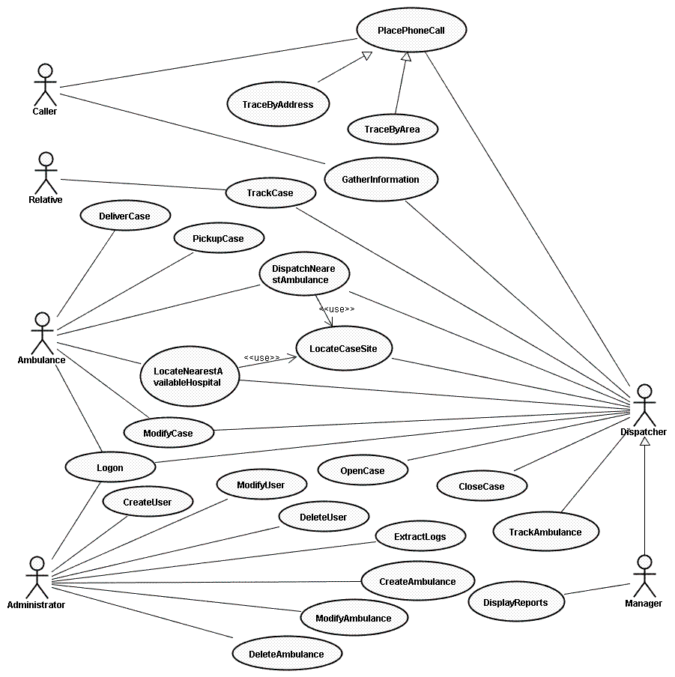

3.4.3 Use Case Specifications and Sequence Diagrams

Table 2 : PlacePhoneCall Specifications

Use case name | PlacePhoneCall
Participating actors | • Caller  • Dispatcher
Description | A caller makes a phone call to 911 asking for medical help. A dispatcher answers the call and acts accordingly.
Flow of events | 1. Caller makes a phone call to 911 for a medical emergency  2. Dispatcher picks up the call  3. System starts recording the call  4. System displays a screen to enable dispatcher to log call details  5. Dispatcher asks about details of the case (dispatchers are trained to handle panicked calls – there are many ways to ask about details, but this is out of the scope of the system)  6. Caller gives details  7. Dispatcher captures required details in system and tells the caller help is on the way
Variations | None
Entry condition | • Caller calls 911 asking for medical help  • Dispatcher is logged on (see Logon use case)
Exit condition | • Dispatcher captures important information and tells the caller help is on the way
Quality requirements | Phone call must be answered within 1 minute

Table 3 : TraceByAddress

Use case name | TraceByAddress
Participating actors | Inherited from PlacePhoneCall use case
Description | A caller makes a phone call to 911 from a phone number with an identifiable street address asking for medical help. A dispatcher answers the call and act accordingly.
Flow of events | - Caller makes a phone call to 911 for a medical emergency  - Dispatcher picks up the call  - System starts recording the call  - System identifies caller’s exact address  - Dispatcher confirms address with caller  - Dispatcher asks about details of the case (dispatchers are trained to handle panicked calls – there are many ways to ask about details, but this is out of the scope of the system)  - Caller gives details  - Dispatcher captures required details in system and tells the caller help is on the way
Variations | None
Entry condition | Inherited from PlacePhoneCall use case
Exit condition | Inherited from PlacePhoneCall use case
Quality requirements | Inherited from PlacePhoneCall use case

Table 4 : TraceByArea

Use case name | TraceByArea
Participating actors | Inherited from PlacePhoneCall use case
Description | A caller makes a phone call to 911 from a cell phone whose area can be identified asking for medical help. A dispatcher answers the call and act accordingly.
Flow of events | 1. Caller makes a phone call to 911 for a medical emergency  2. Dispatcher picks up the call  3. System starts recording the call  4. System identifies caller’s approximate area  5. Dispatcher confirms address with caller  6. Dispatcher asks about details of the case (dispatchers are trained to handle panicked calls – there are many ways to ask about details, but this is out of the scope of the system)  7. Caller gives details  8. Dispatcher captures required details in system and tells the caller help is on the way
Variations | None
Entry condition | Inherited from PlacePhoneCall use case
Exit condition | Inherited from PlacePhoneCall use case
Quality requirements | Inherited from PlacePhoneCall use case

Table 5 : Gather Information

Use case name | GatherInformation
Participating actors | • Caller  • Dispatcher
Description | Dispatcher collects details and location of the emergency case
Flow of events | 1. System displays address or area information if available  2. Dispatcher asks caller about details of emergency  3. Caller provides dispatcher with as much details as possible  4. Dispatcher enters emergency details into system  5. Dispatcher searches for location
Variations | None
Entry condition | • Dispatcher is logged on (see Logon use case)
Exit condition | • Emergency location is identified
Quality requirements | • Search for an address should not exceed 15 seconds

Table 6 : Open Case

Use case name | OpenCase
Participating actors | • Dispatcher
Description | Dispatcher opens a case to track an emergency case
Flow of events | 1. Dispatcher receives a call for a medical emergency  2. Dispatcher initiates a transaction in the system to track this call  3. Dispatcher records date and time of call, details of emergency, etc.  4. Dispatcher saves case information
Variations | None
Entry condition | • Dispatcher identifies a call as a medical emergency  • Dispatcher is logged on (see Logon use case)
Exit condition | N/A
Quality requirements | N/A

Table 7 : Track Ambulance

Use case name | TrackAmbulance
Participating actors | • Dispatcher
Description | Dispatcher has a mechanism to identify location of an ambulance
Flow of events | 1. System provides a transaction to search for ambulances  2. Dispatcher searches for an ambulance using its number or driver name  3. System provides a list of matching ambulances  4. Dispatcher selects an ambulance  5. Ambulance location is identified on a map and physical address is written on the screen
Variations | None
Entry condition | • Dispatcher is logged on (see Logon use case)
Exit condition | N/A
Quality requirements | N/A

Table 8 : Locate Case Site Specification

Use case name | LocateCaseSite
Participating actors | • Dispatcher
Description | Dispatcher can identify the location of the emergency case on a map
Flow of events | 1. System provides a transaction to search for a street address  2. Dispatcher types available address information  3. System highlights address on a map  4. Dispatcher acknowledges the address is correct  5. System saves the address with the opened case
Variations | None
Entry condition | • Dispatcher is logged on (see Logon use case)  • Dispatcher collects enough address information to look for location on map
Exit condition | N/A
Quality requirements | N/A

Table 9 : Dispatch Nearest Ambulance Specification

Use case name | DispatchNearestAmbulance
Participating actors | • Dispatcher  • Ambulance
Description | Dispatcher sends the ambulance nearest to the emergency location to handle the case
Flow of events | 1. System provides a transaction to dispatch ambulances  2. Dispatcher enters a case number  3. System locates the nearest three ambulances to case location  4. System suggest which ambulance to dispatch  5. Dispatcher selects an ambulance  6. Dispatcher contacts ambulance  7. System transfers case & location information  8. Ambulance acknowledges the case and moves
Variations | None
Entry condition | • Dispatcher is logged on (see Logon use case)  • Ambulance is logged on (see Logon use case)  • Dispatcher is able to locate emergency site
Exit condition | • An ambulance is successfully dispatched
Quality requirements | • An ambulance must be dispatched in no more than 3 minutes  • If 11 minutes pass by without dispatching an ambulance, the system raises an exception

Table 10 : Locate Nearest Available Hospital Specifications

Use case name | LocateNearestAvailableHospital
Participating actors | • Dispatcher  • Ambulance
Description | Dispatcher locates nearest available hospital to emergency site
Flow of events | 1. Dispatcher enters case number  2. System retrieves case location  3. System identifies nearest three hospitals to case  4. Dispatcher makes sure hospital can receive patient  5. Dispatcher contacts ambulance and recommends a hospital  6. System transfers hospital location to ambulance
Variations | None
Entry condition | • Dispatcher is logged on (see Logon use case)  • Dispatcher is able to locate emergency site  • Dispatcher is not handling any other call
Exit condition | N/A
Quality requirements | N/A

Table 11 : Track Case Specifications

Use case name | TrackCase
Participating actors | • Relative
Description | Relative checks latest status of case
Flow of events | 1. Relative chooses option to track case  2. Relative inputs data about patient  3. System looks up the information  4. System displays up to date status  5. Relative exits the system
Variations | None
Entry condition | Relative chooses option to track case
Exit condition | Relative exits the system
Quality requirements | N/A
Table 12 : Modify Case Specifications

Use case name | ModifyCase
Participating actors | • Dispatcher  • Ambulance
Description | Case is updated based on new information received
Flow of events | 1. User selects option to update case  2. User enters new information about the case  3. System asks for confirmation of update  4. User confirms update  5. System stores new information  6. User exits the section
Variations | 3.a User cancels update  3.b System does not store new information  3.c User goes back to (2) or (6)
Entry condition | Dispatcher or ambulance is logged into the system
Exit condition | User exits section
Quality requirements | N/A

Table 13 : Pick Up Case Specifications

Use case name | PickUpCase
Participating actors | • Ambulance
Description | Patient is picked up by ambulance
Flow of events | 1. Ambulance receives information about patient  2. Ambulance gets to the scene  3. Ambulance picks up patient  4. Ambulance updates case information
Variations | N/A
Entry condition | • Ambulance receives notification about patient
Exit condition | Ambulance picks up patient
Quality requirements | N/A

Table 14 : Deliver Case Specifications

Use case name | DeliverCase
Participating actors | • Ambulance
Description | Ambulance delivers the patient(s) to an emergency room
Flow of events | 1. Ambulance picks up patient  2. Paramedic monitors patient’s condition  3. Ambulance gets to ER  4. Ambulance delivers patient to ER  5. Ambulance updates case information
Variations | N/A
Entry condition | • Ambulance picks up patient
Exit condition | Ambulance delivers patient to ER
Quality requirements | N/A

Table 15 : Logon Specifications

Use case name | Logon
Participating actors | • Dispatcher  • Ambulance
Description | A user logs into the system
Flow of events | 1. User accesses the system via a terminal  2. User enters username and password on welcome screen  3. System verifies information  4. System grants access to user
Variations | 3.a System does not recognize user  3.b Access is not granted  3.c System asks user to re-enter information (2)
Entry condition | N/A
Exit condition | User logs out
Quality requirements | N/A

Table 16 : Display Reports Specifications

Use case name | DisplayReports
Participating actors | • Manager
Description | Reports about cases are displayed
Flow of events | 1. Manager logs onto the system  2. Manager chooses to display reports from menu  3. System retrieves stored information about cases  4. System generates a visual report  5. System displays information  6. Manager logs out
Variations | N/A
Entry condition
Exit condition | User logs out
Quality requirements | N/A

Table 17 : Create User Specifications

Use case name | CreateUser
Participating actors | • Administrator
Description | Administrator creates user
Flow of events | 1. Administrator logs into the system  2. Administrator goes to section to add new user  3. Administrator enters new information  4. System asks for confirmation  5. Administrator confirms data  6. System records new user  7. Administrator exits system
Variations | 4.a Administrator cancels update  4.b Administrator goes back to (3) or (7)
Entry condition | N/A
Exit condition | User logs out
Quality requirements | N/A

Table 18 : Modify User Specifications

Use case name | ModifyUser
Participating actors | • Administrator
Description | Administrator changes user
Flow of events | 1. Administrator logs into the system  2. Administrator goes to section to modify a user  3. Administrator enters new information  4. System asks for confirmation  5. Administrator confirms data  6. System records new information about user  7. Administrator exits system
Variations | 4.a Administrator cancels update  4.b Administrator goes back to (3) or (7)
Entry condition | N/A
Exit condition | User logs out
Quality requirements | N/A

Table 19 : Delete User Specifications

Use case name | DeleteUser
Participating actors | • Administrator
Description | Administrator deletes user
Flow of events | 1. Administrator logs into the system  2. Administrator goes to section to delete a user  3. Administrator deletes user  4. System asks for confirmation  5. Administrator confirms data  6. System deletes user  7. Administrator exits system
Variations | 4.a Administrator cancels update  4.b Administrator goes back to (3) or (7)
Entry condition | N/A
Exit condition | User logs out
Quality requirements | N/A

Table 20 : Retrieve Logs Specifications

Use case name | RetrieveLogs
Participating actors | • Manager
Description | Manager retrieves logs
Flow of events | 1. Manager logs into the system  2. Manager chooses option to retrieve logs  3. System retrieves logs  4. System displays logs  5. Manager exits the system
Variations | N/A
Entry condition
Exit condition | User logs out
Quality requirements | N/A

Table 21 : Create Ambulance Specifications

Use case name | CreateAmbulance
Participating actors | • Administrator
Description | Administrator creates an ambulance in the system
Flow of events | 1. Administrator goes to function to add a new ambulance  2. Administrator enters new ambulance into system  3. System asks for confirmation  4. Administrator confirms data  5. System saves ambulance information
Variations | N/A
Entry condition | Administrator is logged on
Exit condition | Ambulance is created
Quality requirements | N/A

Table 22 : Modify Ambulance Specifications

Use case name | ModifyAmbulance
Participating actors | • Administrator
Description | Administrator changes information of an ambulance in the system
Flow of events | 1. Administrator goes to function to modify an ambulance  2. Administrator selects ambulance to be changed  3. System displays ambulance’s current information  4. Administrator changes ambulance information  5. System asks for confirmation  6. Administrator confirms data  7. System saves changed ambulance information
Variations | N/A
Entry condition | • Administrator is logged on
Exit condition | Ambulance information is changed
Quality requirements | N/A

Table 23 : Delete Ambulance Specifications

Use case name | DeleteAmbulance
Participating actors | • Administrator
Description | Administrator deletes an ambulance from the system
Flow of events | 1. Administrator goes to function to delete an ambulance  2. Administrator selects ambulance to be deleted  3. System displays ambulance’s current information  4. Administrator selects to delete the ambulance  5. System asks for confirmation  6. Administrator confirms data  7. System deletes ambulance information from system
Variations | N/A
Entry condition | Administrator is logged on
Exit condition | • Ambulance information is deleted
Quality requirements | N/A

Object Model
(Refer Next Page for System Class Diagram)

Figure 2 Class Diagram
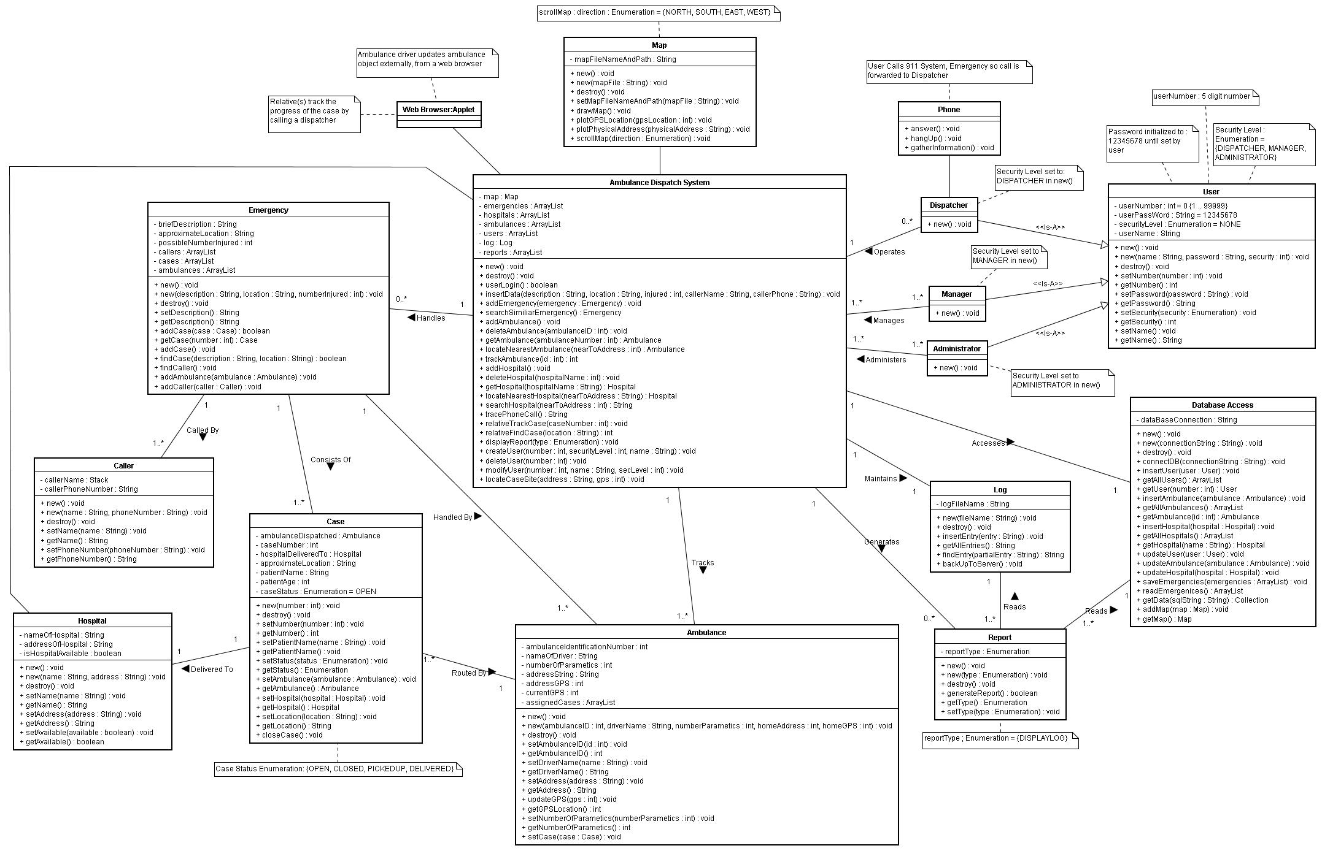

3.4.5 Dynamic Model
The following Sequence Diagrams aid in explaining the behavior of various operations performed by the system and by its actors.

Figure 3 : Trace Phone Call

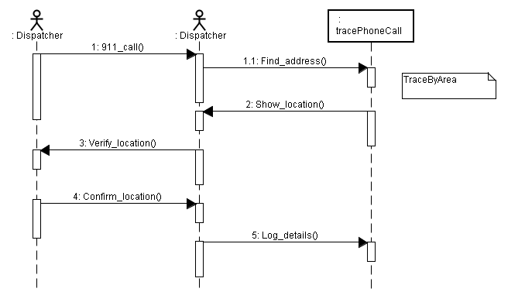

Figure 4 Place Phone Call

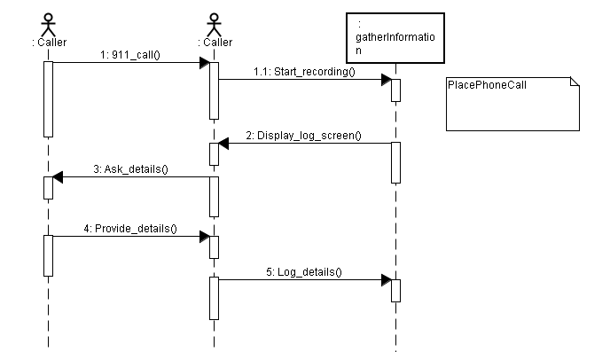

Figure 5 Trace By Address

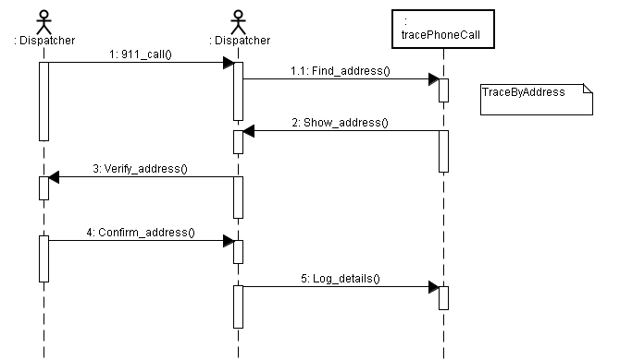

Figure 6 Track Case

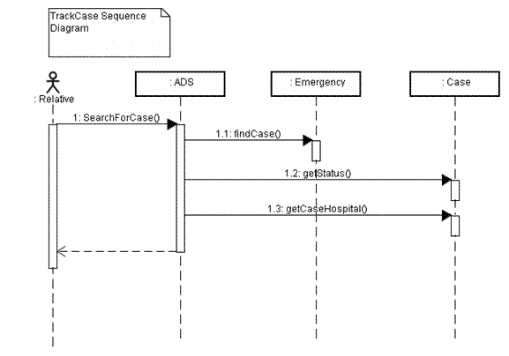

Figure 7 Deliver Case

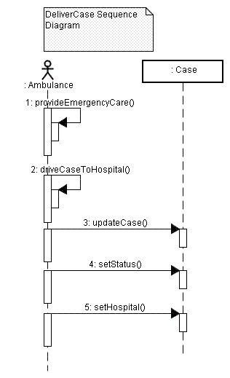

Figure 8 Pick-Up Case

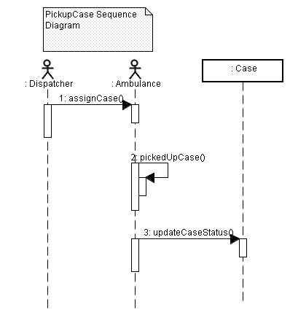

Figure 9 Dispatch Nearest Ambulance

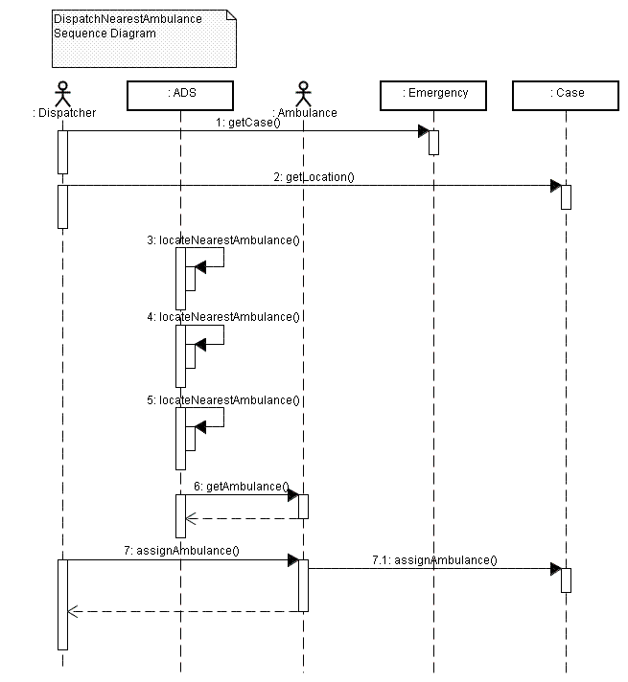
Figure 10 Create Ambulance

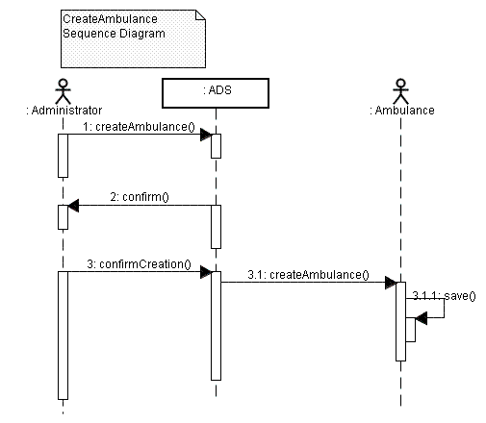

Figure 11 Modify Ambulance

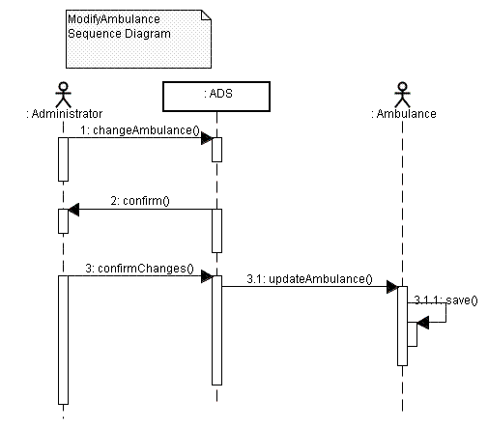

Figure 12 Delete Ambulance

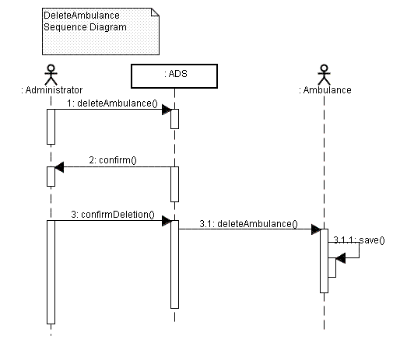
Figure 13 Locate Case Site

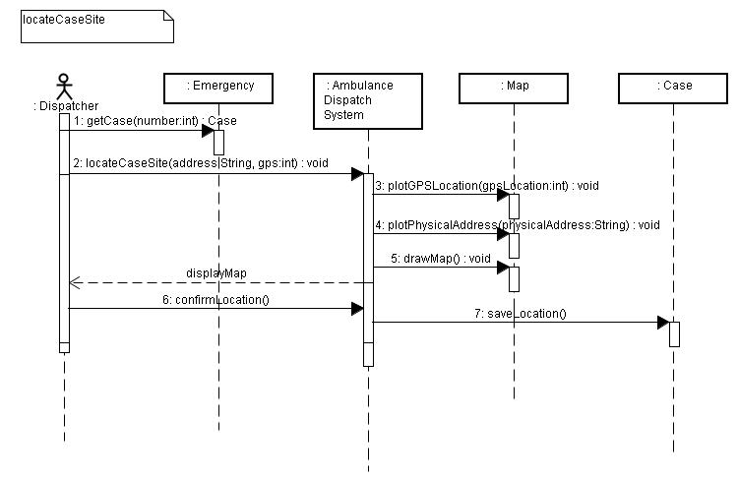
Figure 14 Locate Nearest Available Hospital

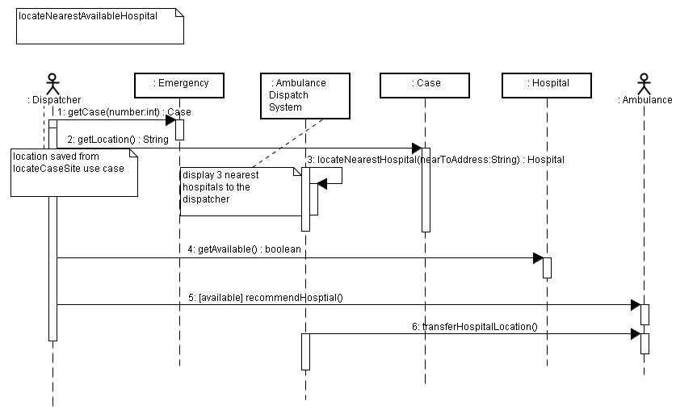

Figure 15 Login

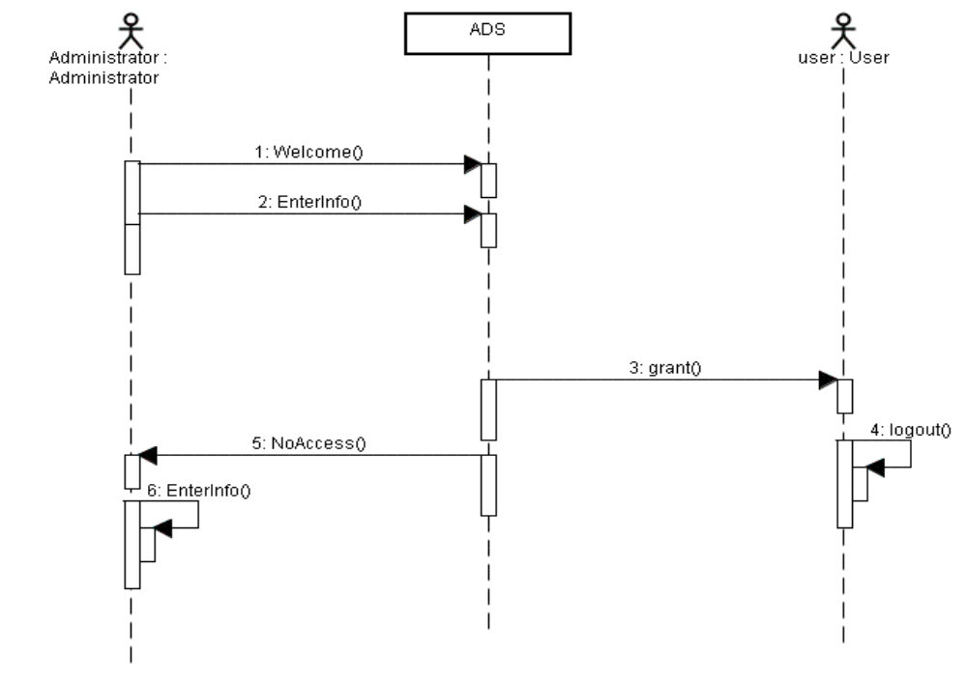

Figure 16 Create User

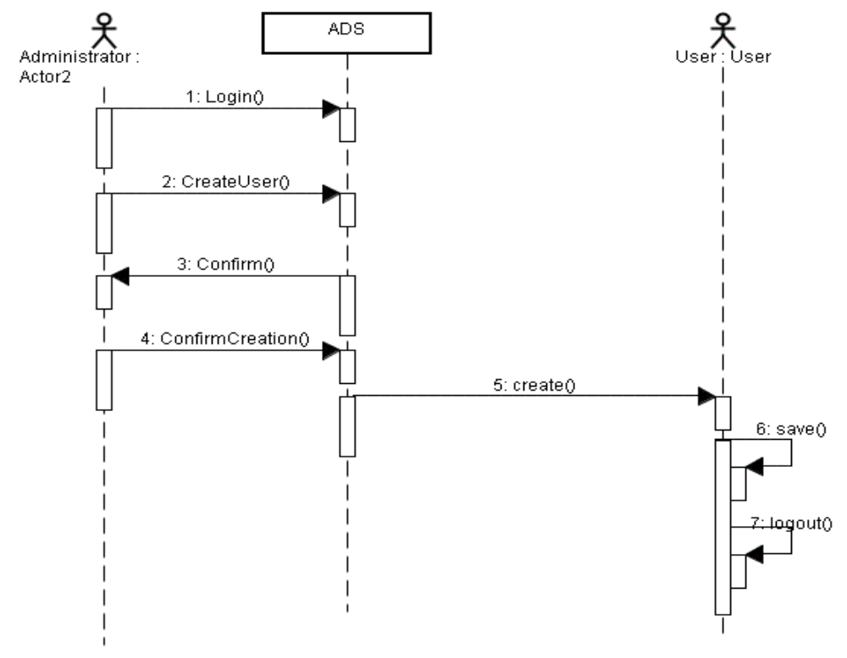

Figure 17 Modify User

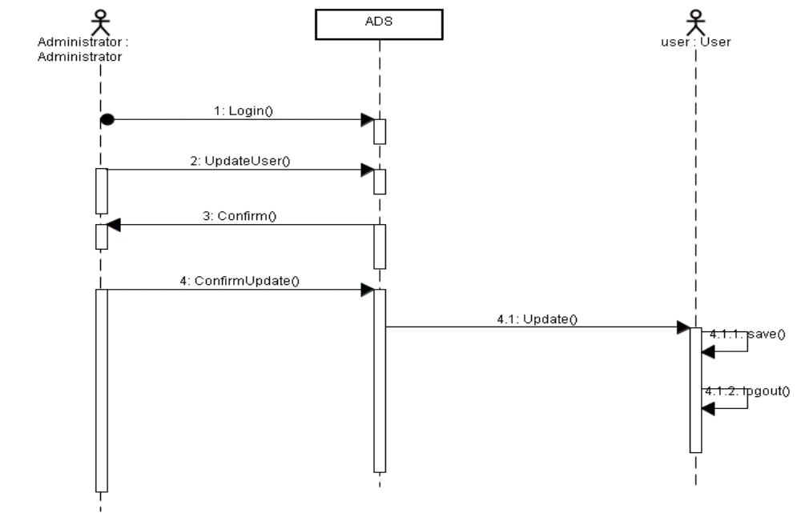

Figure 18 Delete User

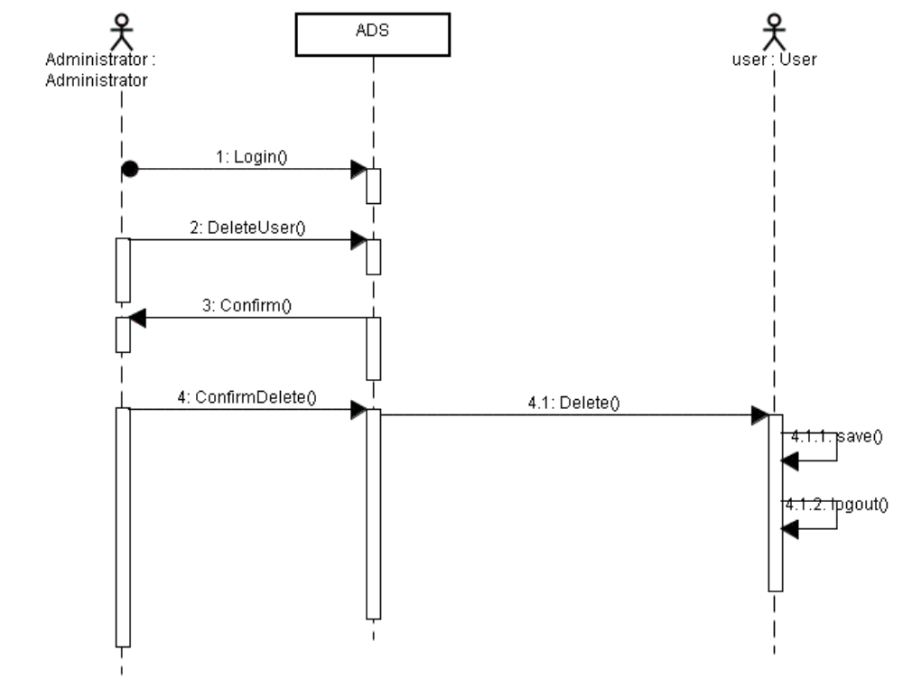
Figure 19 Close Case

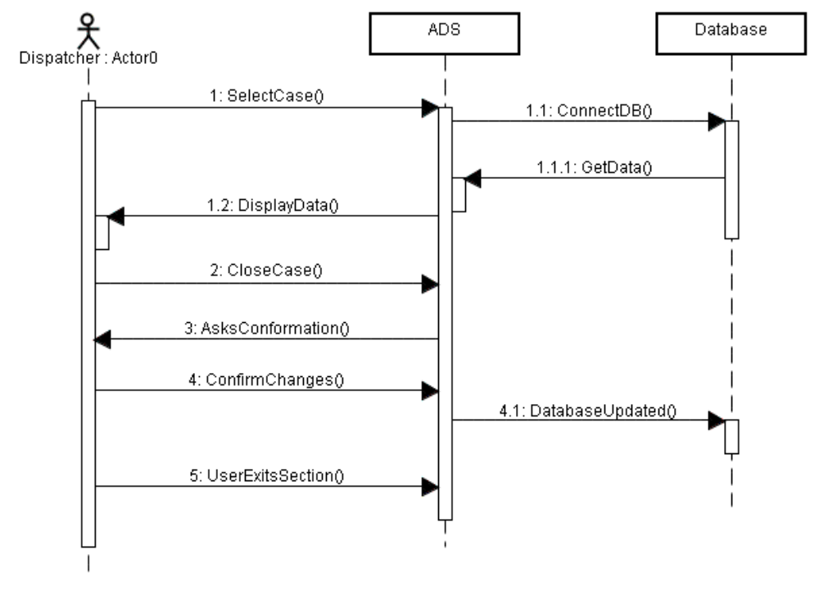

Figure 20 Modify Case
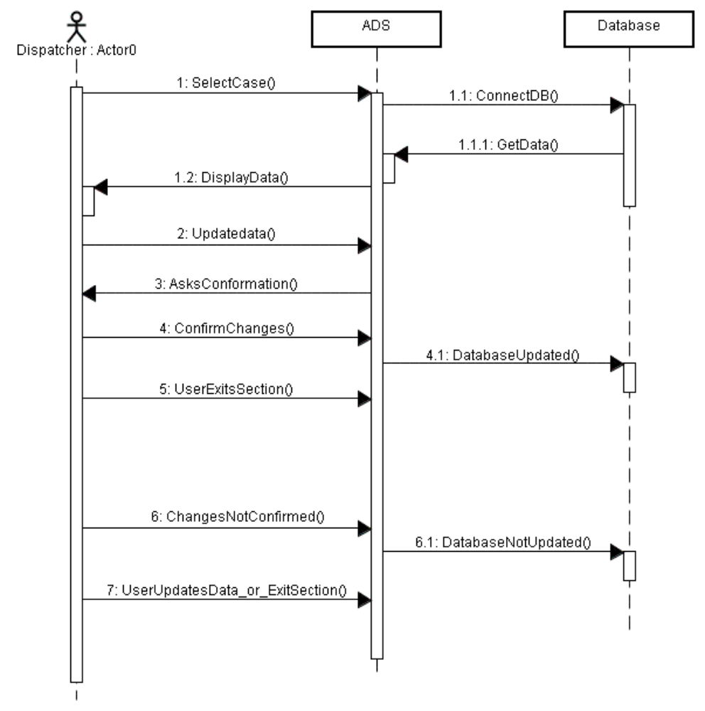

Figure 21 Open Case

User Interface: Navigational Paths and Screen Mock Ups

The Prototype Graphical User Interface Screens for the system are designed as shown below in the next few Pages.

Login Screen
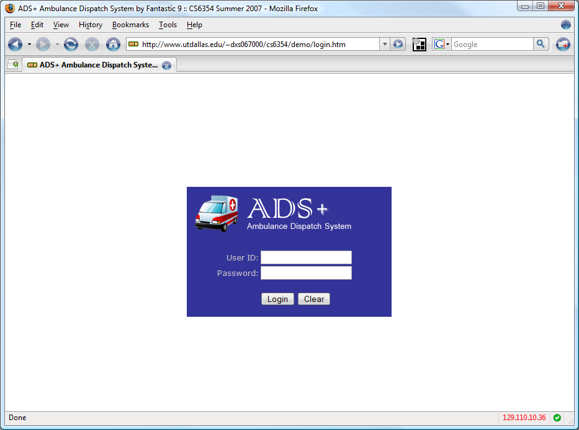
Figure 22 Login Screen

The login screen is a typical Login Screen with a textbox for User ID and a textbox for Password where the user needs to input data to login to the system.

Active Emergencies Screen

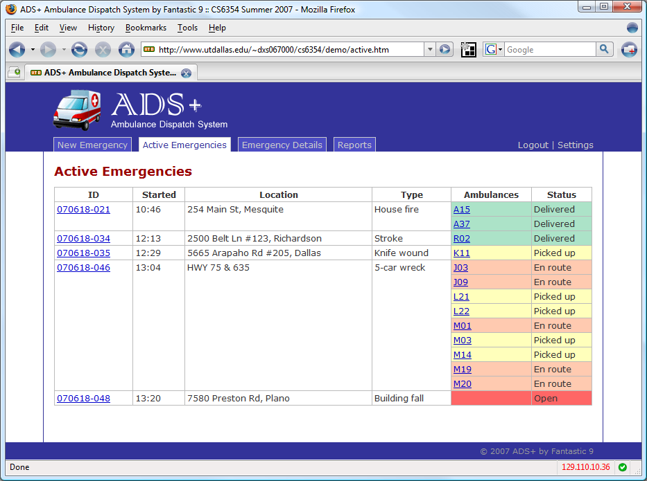
Figure 23 Active Emergencies Screen

- This screen is designed to show all the Active Emergencies by their ID, in the order of the time in which they occurred, along with some other details
- For each Emergency the system displays the Ambulances allocated to it along with their status, color coded for enhancing usability
- The Dispatcher can view/add more information about the Emergency by clicking on the Emergency ID hyperlink
- The Dispatcher can track Ambulance in the Map by clicking on the Ambulance number hyperlink

New Emergency Screen

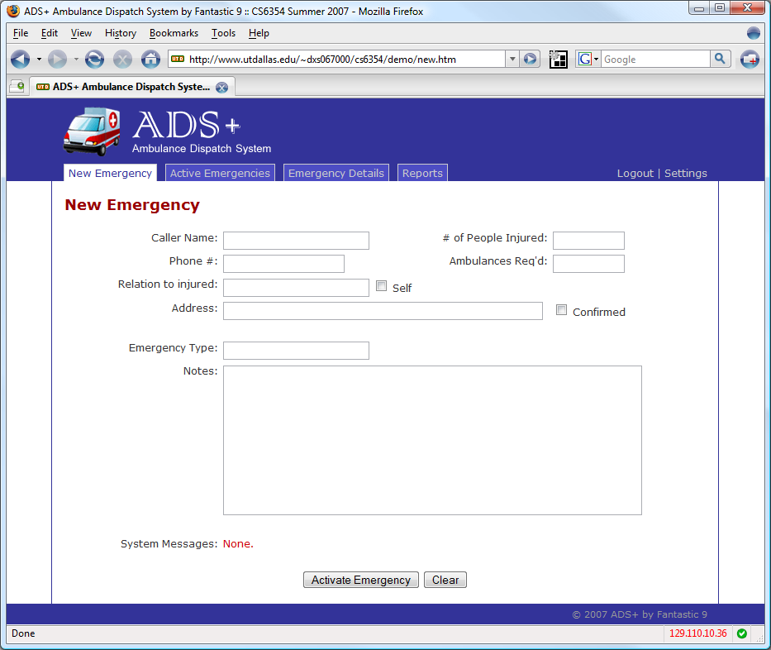
Figure 24 New Emergency Screen

- This screen is used by the Dispatcher to enter details for a New Emergency. There are all these relevant textboxes for the dispatcher to enter information in.
- The System Messages field at the bottom notifies the Dispatcher of important information e.g. identifying duplicate emergencies.

Emergency Details Screen

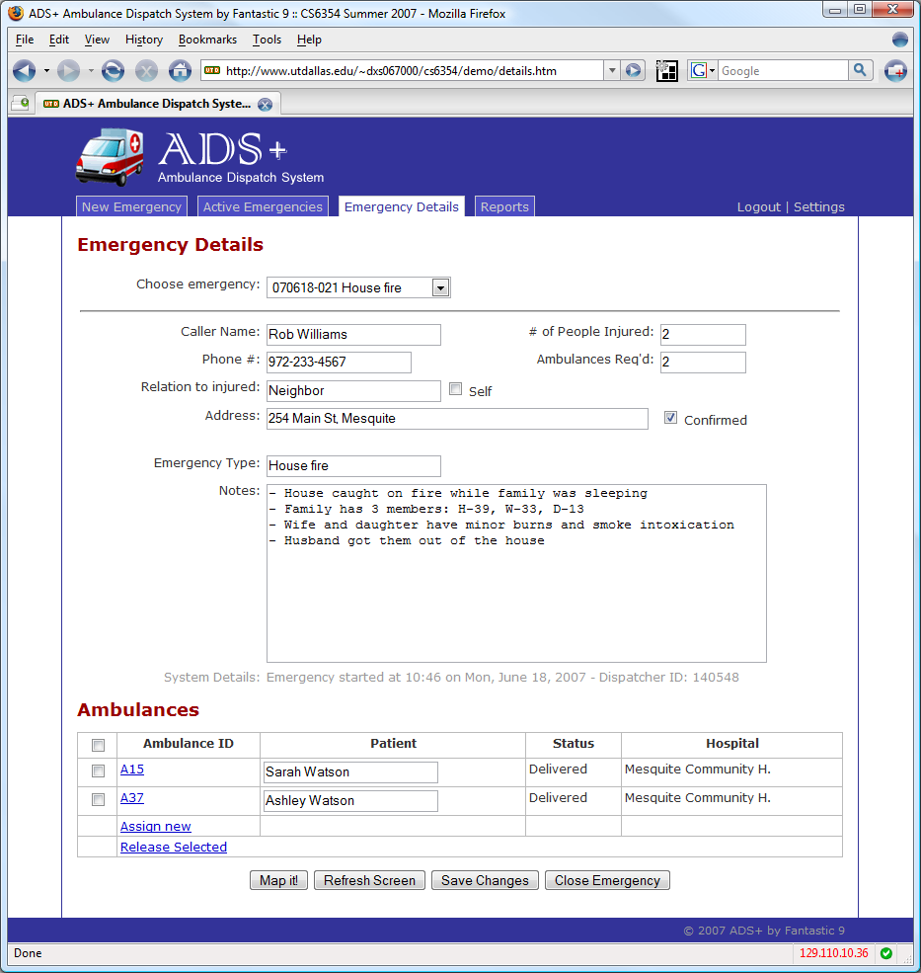
Figure 25 Emergency Details Screen
- The Emergency Details screen allows the dispatcher to update details about any particular Emergency and allocate more or release currently allocated ambulances. It also has the following buttons :
- Map It – The System takes the User to the Map which shows the real-time locations of the Emergency, Ambulances and hospitals
- Refresh – Refreshes the screen with the latest information
- Save Changes – Saves the changes the Dispatcher made to the Screen
- Close Emergency – Allows the Dispatcher to close the Emergency if all the patients for that emergency are delivered to their corresponding Hospitals

3.5 Glossary

Dispatchers | Also called dispatch controller; communications personnel responsible for receiving and transmitting pure and reliable messages, tracking vehicles and equipment, and recording other important information.
System Analysts | Developers who participate in the requirements.
System Designers | Developers who participate in the system design.
ADS | Ambulance Dispatch System
RAD | Requirements Analysis Document, this document.
MTBF | Mean Time Between Failure
MTTR | Mean Time To Repair
GPS | Global Positioning System - uses satellites to triangulate positions on earth.

